ADT Lab 4 (10pts)
Q1
Q2
Q3
Q4

Highlight the questions you are done with to green colour before you submit
Setup Instructions-
- Download the files ADT Lab 4.docx, create_table.sql, insert_table.sql files from canvas.
- Create a new database with your IU username (or use the one that you might have created in previous labs)
- Run the sql commands in create_table.sql to create new tables.
- Run the sql commands in insert_table.sql to populate all the tables.
Questions
- Observe the create queries in the file create_table.sql. There are foreign key constraints on several tables.
Run the quey- SELECT * FROM countries WHERE region_id=3;
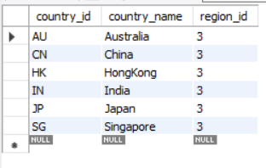

See that we have several records with region_id 3. The column region_id in countries table is a foreign key which references the column region_id in regions table.
SELECT * FROM REGIONS;
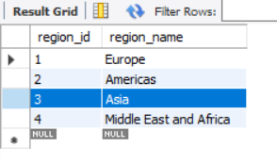
In country table region_id corresponds to the region_name Asia.

Let’s try to delete the region_id 3 from table country.

Run the query-
DELETE FROM regions WHERE region_id=3;
After successfully executing this query, check the countries table again-

SELECT * FROM countries where region_id=3;

It should show an empty result



Why did this happen? Even though we deleted the records from regions table all the records in the country table with region_id=3 vanished.

Write an explanation below with the reason.

Q1 # Write your answer below.
The Foreign Key constraint plays an important role in relational databases by linking data and creating dependencies between columns in the primary and foreign tables. Here, the regions table serves as the parent or primary table, while the countries table is the child or foreign key table that references it. When the ON DELETE CASCADE option is used, deleting a record from the parent table also removes the related records from the child table. For instance, deleting a record from the regions table will automatically delete all corresponding records in the countries table with region_id = 3 and country_name = Asia.

Hint-
https://dba.stackexchange.com/questions/74627/difference-between-on-delete-cascade-on-update-cascade-in-mysql (1st answer)

Research more on Cascade if you need more clarity

- Now let us drop and create a new foreign key constraint
- Note the name of the foreign key constraint under the Foreign Keys list
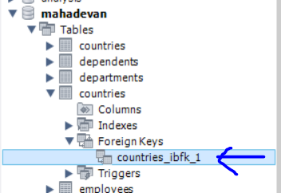

Run the query-

ALTER TABLE countries DROP FOREIGN KEY countries_ibfk_1;

SELECT * FROM countries where region_id=4;
We see the following entries in the county table for region_id=4
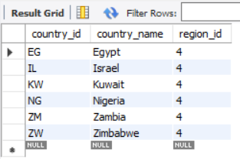

Now let’s delete the region 4 from the regions table using the following query
DELETE FROM regions WHERE region_id=4;

SELECT * FROM REGIONS;
Once deleted we now only have 2 regions in the regions table-
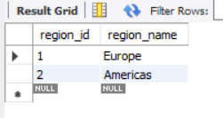

Now let’s check the countries table-
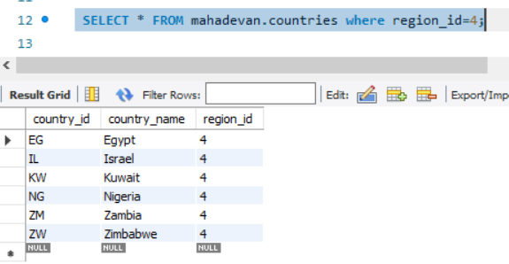

We still have all the entries corresponding to region_id 4 in the countries table even after deleting the region_id 4 in regions table.

Why did this happen?

Q2 # Write your answer below.
Since the Foreign Key in the countries table was dropped earlier in the code, the dependency between the parent and child tables no longer exists, leading to a loss of referential integrity. As a result, the countries table still contains all entries with region_id 4, even though the corresponding record with region_id 4 was deleted from the regions table.

- Now let’s try to delete some tables

DROP TABLE jobs;

You won’t be allowed to delete this table because of the foreign key constraint that is being used in the employees table.

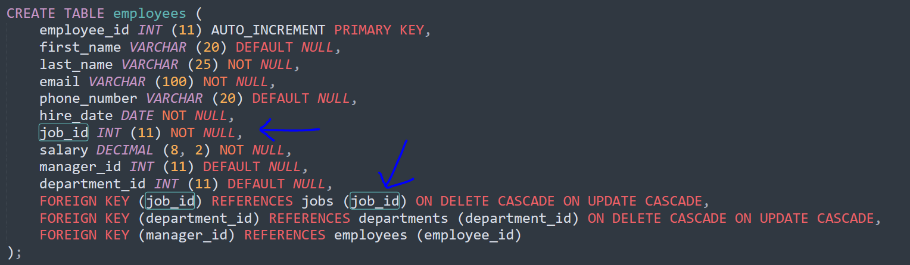

In order to delete the job table, you first need to drop the foreign_key constraint and then delete the table jobs

# Delete the jobs table and post the screenshot below
Hint- First drop the all the foreign key constraint on employee’s table. Then drop the jobs table
ALTER TABLE employees DROP FOREIGN KEY employees_ibfk_1;

#Sample screenshot with no jobs table-
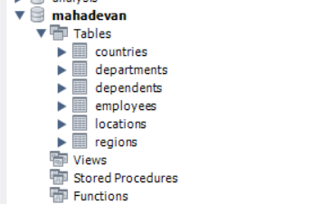

Q3 # Your screenshot


- Now drop the table regions and countries.
DROP TABLE regions;

If you get an error while deleting the countries table that’s because there is a foreign key in the locations table that’s referencing the column country_id in countries table.
So first drop the foreign key constraint from locations table

ALTER TABLE locations DROP FOREIGN KEY locations_ibfk_1;

Now drop the countries table- Drop table countries;
DROP TABLE countries;

Now recreate the countries and region table with the below queries-

CREATE TABLE regions (
region_id INT (11) AUTO_INCREMENT PRIMARY KEY,
region_name VARCHAR (25) DEFAULT NULL
);

CREATE TABLE countries (
country_id CHAR (2) PRIMARY KEY,
country_name VARCHAR (40) DEFAULT NULL,
region_id INT (11) NOT NULL,
FOREIGN KEY (region_id) REFERENCES regions (region_id) ON DELETE RESTRICT
);

INSERT INTO regions(region_id,region_name) VALUES (1,'Europe');
INSERT INTO regions(region_id,region_name) VALUES (2,'Americas');
INSERT INTO regions(region_id,region_name) VALUES (3,'Asia');
INSERT INTO regions(region_id,region_name) VALUES (4,'Middle East and Africa');

/*Data for the table countries */
INSERT INTO countries(country_id,country_name,region_id) VALUES ('AR','Argentina',2);
INSERT INTO countries(country_id,country_name,region_id) VALUES ('AU','Australia',3);
INSERT INTO countries(country_id,country_name,region_id) VALUES ('BE','Belgium',1);
INSERT INTO countries(country_id,country_name,region_id) VALUES ('BR','Brazil',2);
INSERT INTO countries(country_id,country_name,region_id) VALUES ('CA','Canada',2);
INSERT INTO countries(country_id,country_name,region_id) VALUES ('CH','Switzerland',1);
INSERT INTO countries(country_id,country_name,region_id) VALUES ('CN','China',3);
INSERT INTO countries(country_id,country_name,region_id) VALUES ('DE','Germany',1);
INSERT INTO countries(country_id,country_name,region_id) VALUES ('DK','Denmark',1);
INSERT INTO countries(country_id,country_name,region_id) VALUES ('EG','Egypt',4);
INSERT INTO countries(country_id,country_name,region_id) VALUES ('FR','France',1);
INSERT INTO countries(country_id,country_name,region_id) VALUES ('HK','HongKong',3);

Now we will try to delete from the regions table-

DELETE FROM regions WHERE region_id=1;

It will throw an error.

Why did in throw an error?

Q4 # Write your explanation here
When creating and updating the countries table, the ON DELETE RESTRICT command is applied, which prevents any deletion or update of the parent record and instead returns an error. Earlier, as stated in the question, the countries table used ON DELETE CASCADE and ON UPDATE CASCADE, meaning that any change or deletion in the parent record would automatically be reflected in the child table as well.

Hint- It has something to do with the foreign key constraint that we added when we created the table

But you can safely delete records from the countries table (child table).

